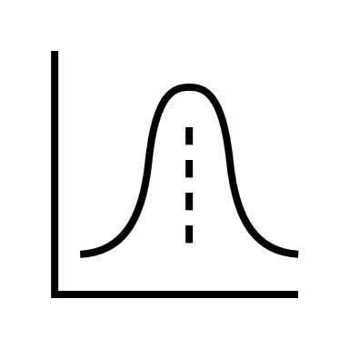

A certain disease has an incidence rate of 0.7% (i.e., the probability a person is infected). A test is carried out to determine who has the disease, but it is not fully accurate. If the false negative rate (i.e., the probability a person tests negative but is infected) is 2.5% and the false positive rate (i.e., the probability a person tests positive but is not infected) is 1.5%, provide the tenths digit of the probability (%) that a person who tests positive is actually infected (i.e., the accuracy of the test).

**Answer**

**Solution**

